COMPONENTS 2 ASSIGNMENT

- For each of component, you will create make sure you are having actions edit , delete , insert option and with listener having value of refreshPage after edit of dialog.
- Subscribe to Our Insights Components from ttn site such that the components needs to be configured once and can be used on all child pages.
- Create a component to represent a News article component that provisions a title, sub-title, author, publish date, description supporting free text and optional image/video.

Solution-

Edit Behavior
The edit behavior of a component is configured by adding a cq:editConfig node of type cq:EditConfig below the component node (of type cq:Component) and by adding specific properties and child nodes. The following properties and child nodes are available:
- cq:editConfig node properties:
  - cq:actions (String array): defines the actions that can be performed on the component.
  - cq:layout (String): : defines how the component is edited in the classic UI.
  - cq:dialogMode (String): defines how the component dialog is opened in the classic UI
    - In the touch-enabled UI, dialogs are always floating in desktop mode, and automatically opened as fullscreen in mobile.
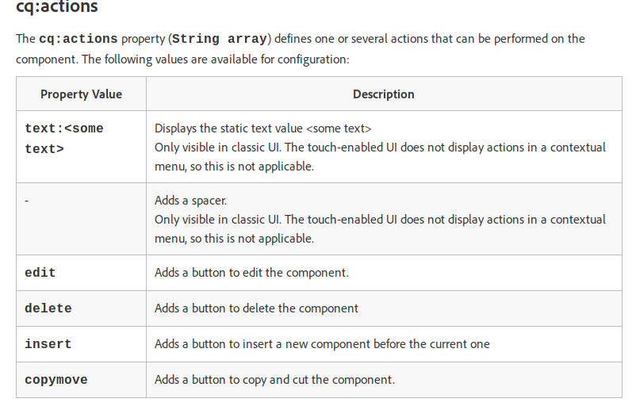

to refresh a page when a component is modified
The cq:listeners [cq:EditListenersConfig] is used to refresh the HTML page after a certain action is performed on a component. The cq:listeners node should be located as shown:
/component-name [cq:Component]
/cq:editConfig [cq:editConfig]
/cq:listeners [cq:EditListenersConfig]
NOTE: Text in the "[]" is the nodetype. Text after "/" is the node name -- should be extact name except for the "component-name".
The following properties are associated with cq:listeners node are:
aftercreate
afterdelete
afteredit
afterinsert
aftermove
afterremove
There are three possible values that can be assigned to the properties above -- either "REFRESH_SELF", "REFRESH_PARENT", "REFRESH_PAGE".
So, if you want your text component to cause a page refresh after each edit, you would create the following structure:
...
/mytextcomponent [cq:Component]
/cq:editConfig [cq:editConfig]
/cq:listeners [cq:EditListenersConfig]
- afteredit {REFRESH_PAGE} <= property {value}
mytextcomponent.jsp <= code

- Subscribe to Our Insights Components from ttn site such that the components needs to be configured once and can be used on all child pages.

If we include a component iside iparsys it is configured once and can be used on all child pages.

- Create a component to represent a News article component that provisions a title, sub-title, author, publish date, description supporting free text and optional image/video.

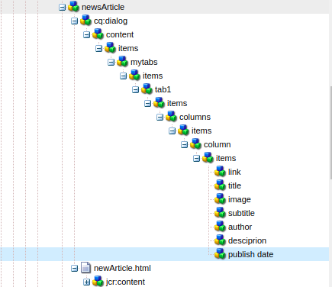
- publish date
SlingResourceType- granite/ui/components/coral/foundation/form/datepicker
- title
SlingResourceType- granite/ui/components/coral/foundation/form/textfield
- sub-title
SlingResourceType- granite/ui/components/coral/foundation/form/textfield
- author
SlingResourceType- granite/ui/components/coral/foundation/form/textfield
- description
SlingResourceType- granite/ui/components/coral/foundation/form/textarea
- optional image/video
SlingResourceType- granite/ui/components/coral/foundation/form/fileupload

